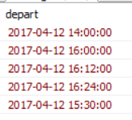

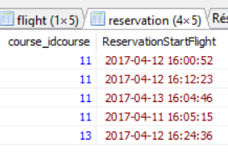

Inner join =

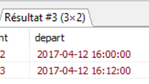

SQL [EXCEPT Clause](https://www.tutorialspoint.com/sql/sql-except-clause.htm) : combines two SELECT statements and returns rows from the first SELECT statement that are not returned by the second SELECT statement.